Captura de pantalla de clave generada 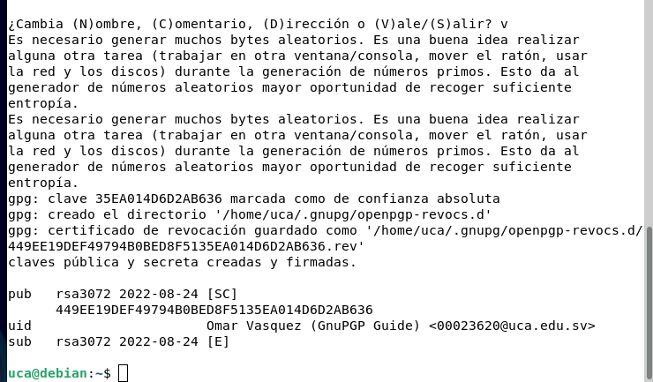

Lista de claves importadas (miguel y néstor)

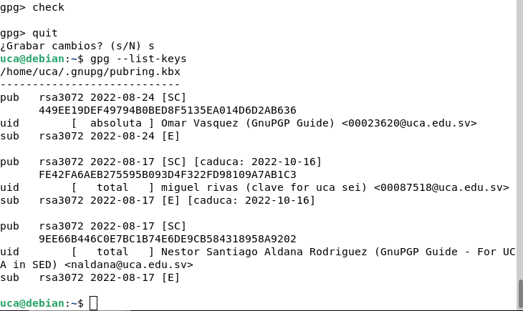

Copia de seguridad de su clave privada y publica en aseii

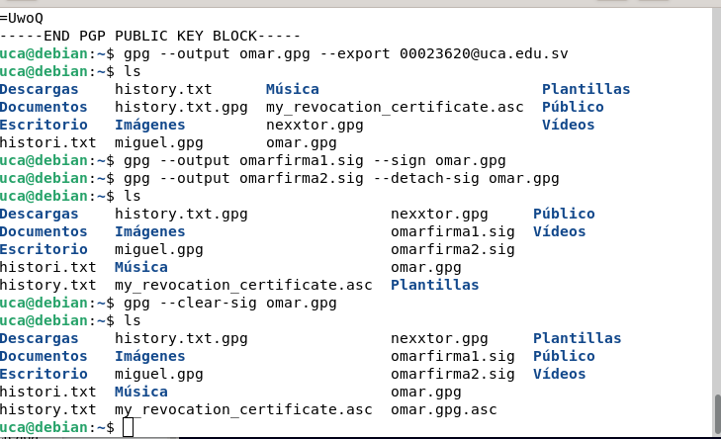

Captura y archivo de cifrado simétrico

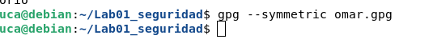

Captura del repositorio de github

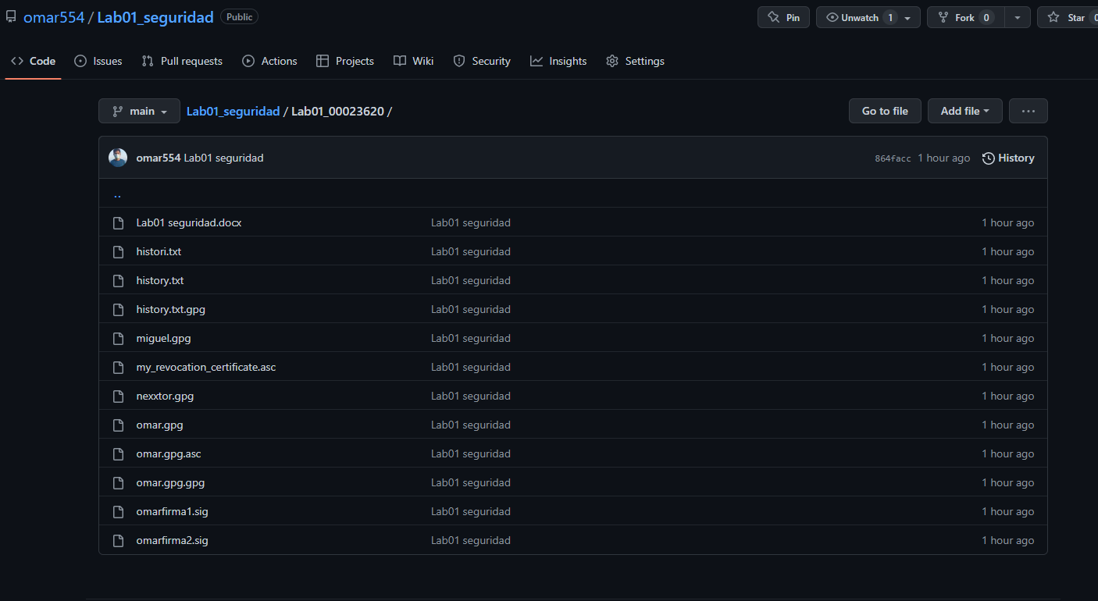

Añadiendo clave GPG a Gitub

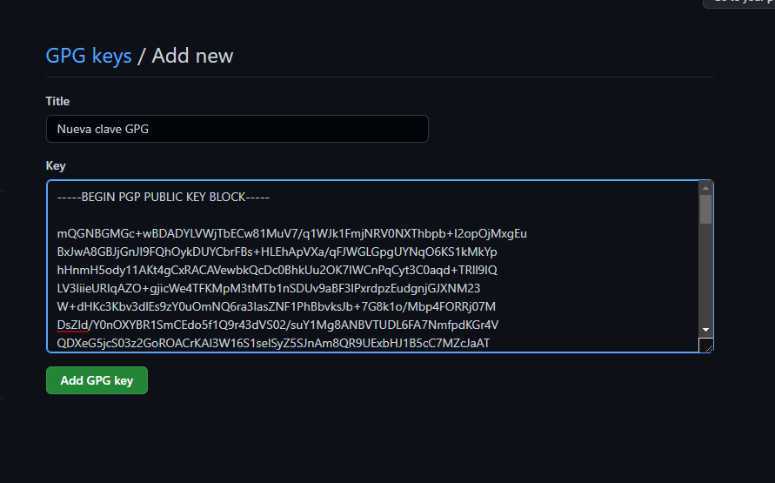

Clave publica

-----BEGIN PGP PUBLIC KEY BLOCK-----

mQGNBGMGSegBDACRUwIYY0CnrEHYOALZ7R4s7sKXwu9UipjR+7mkbSDErRsUXhRh

NfbqXtS/TNqai8ABwJ2/hrnSQkPFF35b6KLl6AOulVbpWZ6cWQXtzzMYR0CqJKNS

103huWPyw2b65MZqQpp8ovhCeFFQWccyQij4ZFXBYnVIy5G9Gj7ZVN8VIFIHVf3n

zjWKmkP2GZyJX4Bkf/ABzW7WrrKPw1mNq6fYNDKObTHuodhrL8SK3JvGGjMcC1wn

1hvmQRjoDxF691c1lzdeQtp9ivtFzSVuDsMxxnK5PgZYwRXq+IKX2D1N6WQ/6d/Y

uAGL9t+Nd8j1hB4oMxQEaS2ydz3Uj2R7mYaa9z+v6WF1H1crGQ0/Cc4oC32wfFwS

Fl0SU1kmx9n2rCrx+FK8P0I/IV4gdkdjmG7/tE8NbZ9XdNIOChBKZAYiBsrP591b

s/l8dH4h9zp7cXiFOUG4Uz/7mszbv+FdY13pf9PFH3RQ3+bON1hu0ew3ZLqaoBEa

shDvLBOEomi2oesAEQEAAbQxT21hciBWYXNxdWV6IChHbnVQR1AgR3VpZGUpIDww

MDAyMzYyMEB1Y2EuZWR1LnN2PokBzgQTAQoAOBYhBESe4Z3vSXlLC+2PUTXqAU1t

KrY2BQJjBknoAhsDBQsJCAcCBhUKCQgLAgQWAgMBAh4BAheAAAoJEDXqAU1tKrY2

UlEL/ivXfxtJb8knlB+KuS/grmbENXETKqqm4jirfubs9f/rgJ60pDGLYEP61KPW

E7dNJLon7MjYZxCqz4AoVVRJQwNZi1+qhrGYZpQyx718NzgvwjayIvOpVY2QliUb

tJFL+rvhRMVMDc0DKZGvNw2/9jRraSF2wwY6pcjykbMZfKdp/ZlHz3PDiBZBPOsb

3/teE4x5usVuNMBRN4XCLoxB8BucRD55f8+H54IAOztqVJdCEi9uJGdKs/kRmGvf

M6jcHCTtzSW+Y7gJSQbNEPc7mngpsKOkiqN53Gb8XqpoGX5VNwMHLsJwP71KhjOm

uXYjBh+r1hMbTFnCa+QnJWkFO0+1alWHG1xpmyN/9NVSWtmmQr4jfy1ls9ulQEjL

7q08u6swdyw6sladB3gFeVj2BXCNPkucVmdDtc0WVC1uNEhHHkjX02Lyh1+XTi9t

LmEE/yRZ5cdHlFN9PicnPREtOcOHZiEe1AL/eYjN2iWKXyTl0DTuL/SPnsNupLHb

+yAhl7kBjQRjBknoAQwAsB5QhDZHDE8mOraSkSUO2iGrKscaT38m+oyJXdWb+tAS

QJr80h0oTqDN1M/TTFlBChmanCterM4wnMizg6LxswZlRdObC1n2UxcHMmdf9Gt+

OUrFdBnRjTAlGBe3b8Npk4j+4qMjFyonac2gHHt7omskaUBNpd/DqPKdS+hEQFHj

Yp6PWvSHrITMtIvJWjDNwvxPSgRjKk3Akdx0c5G0ns3PItzqaTWW04Bm48BprKlg

Dz3N86Yn4w+80h1Mp6vdtw5oWKCkxidxmLY/evk+SOMHcBIDL8xpOKYSqcbXWWdM

7RcSxmzcysUHOnmXfiuUo+Le2ha5Ncu1k9N3fcYs+qiHDknsvHhEX2Rv8LH2g+P/

LjoXeL1mxSsVbt3Wmg1wiGlvi+0V0Qm1yhCdgEoPDgbsQRyflODdwI0C0WG8c2Ds

fSaThruTdSIXWqkVm3nYbWEwU69djpd2cKf/Z/GZKQn58vU/CCDIf8nhbVZ1ELQm

0ep92f8UelYyg6pE2ZOvABEBAAGJAbYEGAEKACAWIQREnuGd70l5Swvtj1E16gFN

bSq2NgUCYwZJ6AIbDAAKCRA16gFNbSq2NjzlC/9EwRzvbzM/q83e8FmGGTQL7yVV

OhpD1CgSrkE9WWRcowpal5qzrhHXk2eN8rbLmjPhyou7l3jC9+sqYXN0sBEQYwAL

d4AsgKdtmBBKlhoQD19TGFKeRr0fPSy9L1xEG0QtvvZfNyCgGNcSaawLNznGcjXq

Oa06PJEtluvUgctiwAkqZoFhsVLsUcnOQO8ZFiZL0tZnEN2mB6+v60jfy2QEFIfw

A2DJTdE24SQVPkD7Sg4TFozgLHmtwW/o5Lpgs40lFVm1CXxZFOFZxpyQMg5kZFRp

6eRbFz7lcFxU6/4LZdXsNDQ6PgQpWFKO0UlwMCJ7WRmwGnUBWuHZtvEUu1WSol58

HKOFiUWV43xxFpWoQnhFaeS3xndzptdJSRpS1fT0FuhnlywlHFoFx1JWVtf7bf8o

Mi/hLEZyXP4kpYyFZpYxFiJ096DsFZn2ebwPYxkvq13eE/3if6o0NNn2l9c8tVFG

nuOsul0s0qlp556U1BboF4V0v0FCVSdHm7BMkaE=

=UwoQ

-----END PGP PUBLIC KEY BLOCK-----